Department of Basic Science Engineering & Humanities
Academic Year: 2024-25

A Group Activity Report On
ATRIA EDUEATS

SUBJECT: INNOVATION AND DESIGN THINKING (BIDB258)

SUBMITTED BY : USN:

ABHIJEET KRISHNA 1AT24CS005
AMULYA P 1AT24CS017
ANJALEE 1AT24CS020
AYUSH KUMAR SINGH 1AT24CS034
AYUSH S 1AT24CS035
B K BHOJRAJ 1AT24CS039
C YOGEETHA 1AT24CS045
CHEERAG N 1AT24CS046
DHANUSH N RAGI 1AT24CS054
FARDEEN IQBAL SAYED 1AT24CS057
GOUTHAMI P M 1AT24CS067
HARI HARAN 1AT24CS068
HARSHINI D 1AT24CS072
INDRAJA A 1AT24CS077
J C MONISHA 1AT24CS078
JOSHUA JEBAASIR 1AT24CS082
K ARUNA PATIL 1AT24CS083
KARTHIK K 1AT24CS089
KEERTHANA K L 1AT24CS091

Under the Guidance of:
Prof Rohith K N

INDEX

SL.NO | CONTENTS | PAGE.NO
1 | Introduction | 3
2 | Key Concepts | 4-5
3 | Uses | 6
4 | Advantages | 7
5 | Parts list | 8
6 | Website Interface Overview | 9-12
7 | Explaination | 13
8 | Conclusion | 14

INTRODUCTION
ATRIA EDUEATS: An Innovative Educational and Food Platform.
In the current era of digital transformation, educational institutions are rapidly evolving to provide holistic student experiences that go beyond traditional academics. ATRIA EDUEATS is a revolutionary web platform conceptualized and designed to blend two critical aspects of student life — Academics and Food Services — into a seamless, interactive, and user-friendly digital space.

❖ The platform comprises two primary dashboards:

- BRAIN BOARD – A complete academic dashboard for students.

- CAMPUS BITES – A centralized food ordering and management system for campus outlets.

KEY CONCEPTS

Dual Dashboard Design:
Landing Page offers navigation to two separate but interconnected dashboards.

BRAIN BOARD Dashboard Features:

- Student Profile Section
- Academic Results Viewer
- Attendance Tracker
- Subjects Overview (e.g., Applied Mathematics, Python, Chemistry)
- College Clubs Directory
- Upcoming Events & Calendar
- Exam Schedule
- Notes & PYQs Repository
- Academic Calendar Display

CAMPUS BITES Dashboard Features:

Outlets Covered:
- Nandini Parlor

- Hotel Udupi Bhavan

- Naveen’s Condiments

- East Fast food

Features:
- Menu with Images & Prices

- Add to Cart & Live Order Tracking

- Multiple UPI Payment Options

- Ratings & Reviews

User Experience (UX):
- Mobile-responsive layout with clean, minimalistic design.

- Smooth 3D transitions (using GSAP/Three.js).

- Easy navigation and intuitive interface.

USES

- Centralized Access to academic and food services for students.

- Improved Productivity with academic tools and reminders.

- Campus Food Management streamlined through digital orders and live tracking.

- Enhanced Engagement through club participation, events, and feedback.

- Digital Repository of notes and question papers for better preparation.

ADVANTAGES

For Students:

- One-stop portal for academic and lifestyle needs.
- Access to digital academic resources and food menus.
- Real time tracking of academic and food orders.
- Personalized dashboard experience.
- Encouragement to engage in college life through clubs and events.

For Administration:

- Organized data collection (attendance, results, feedback).
- Improved communication with students via events and calendars.
- Insights into food order trends and academic performance.

PARTS LISTS
- Frontend Technologies

- HTML, CSS (Tailwind/Bootstrap), JavaScript

- Three.js / GSAP for 3D effects

- VS Code for development

- Authentication

- Firebase Auth (Google & Email sign-in)

- Hosting & CI/CD

- Netlify or Firebase Hosting for deployment

- Version Control

- GitHub (with branches and CI pipelines)

EDUEATS AND EDUPORTAL-INTERFACE OVERVIEW

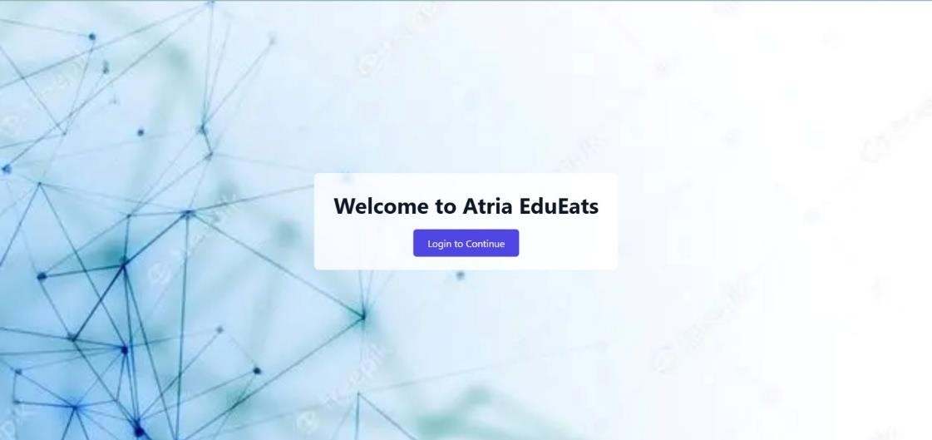

1. Login page of the Atria EduEats app. Users authenticate themselves to access services like food ordering and account management.

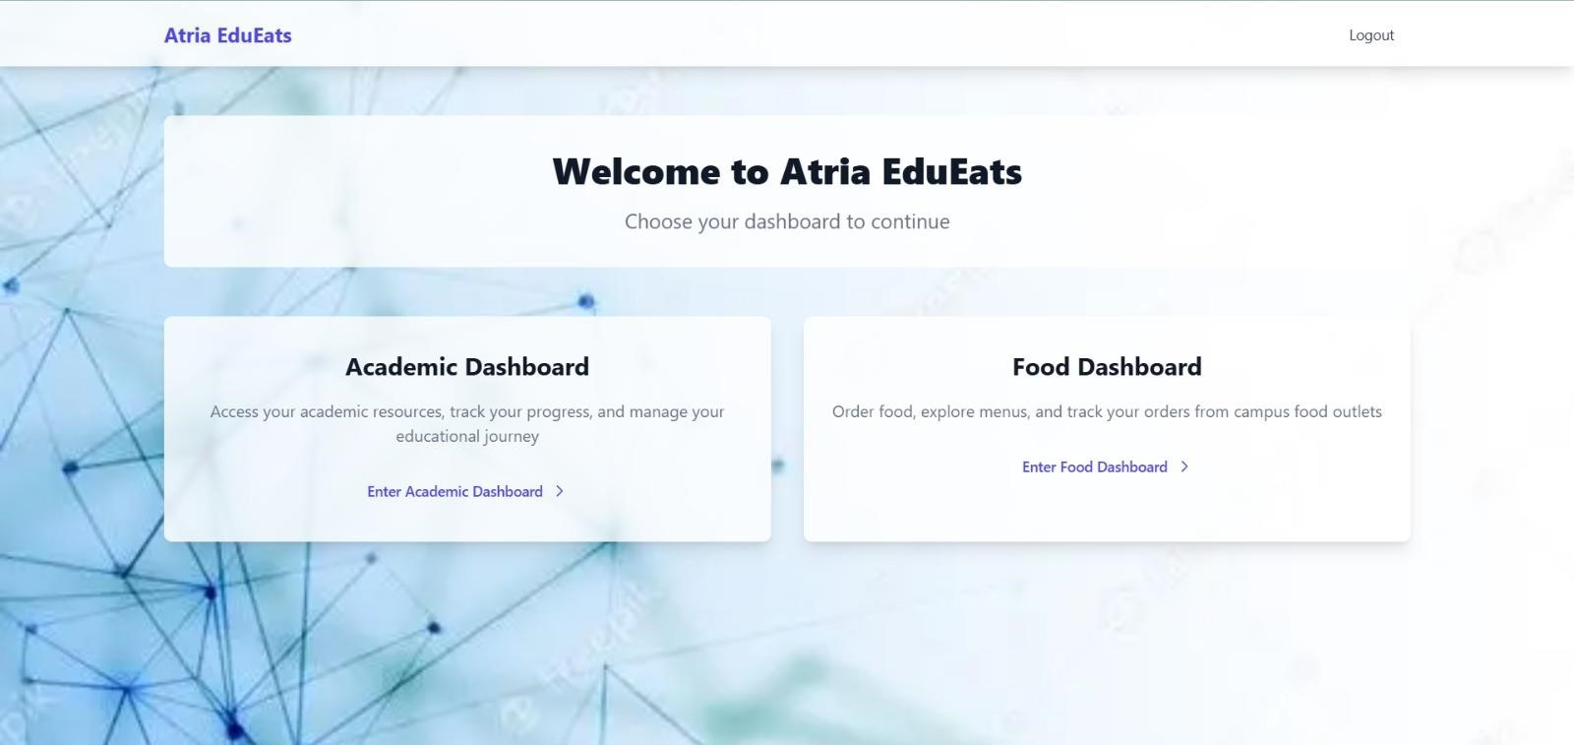

2. Home dashboard of the EduEats app showing key navigation options. Users can access various modules like food menu and order history.

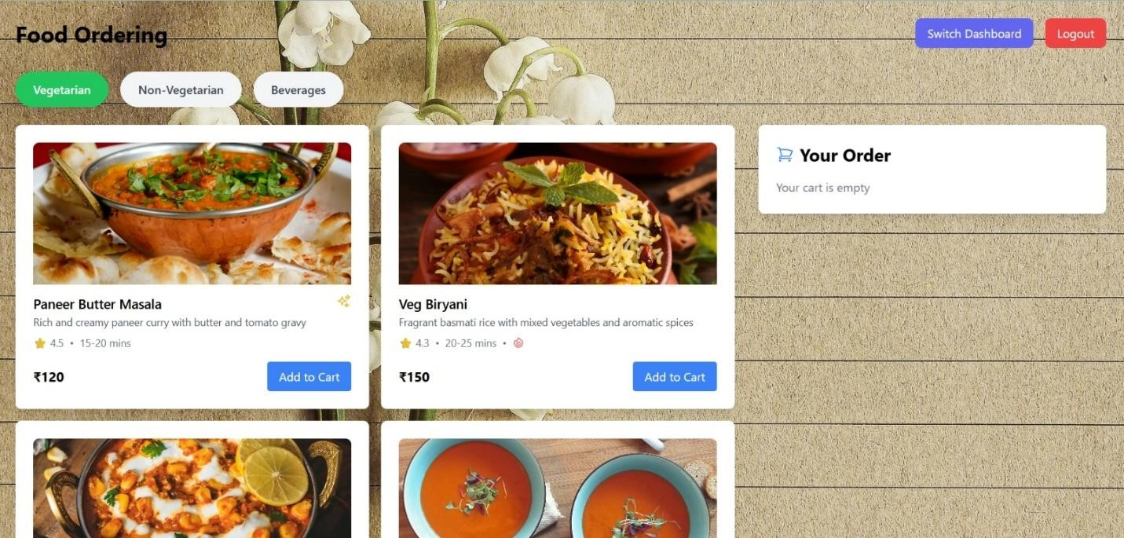

3. Menu section of EduEats displaying available food items. Users can browse, select, and add meals to their cart for ordering.

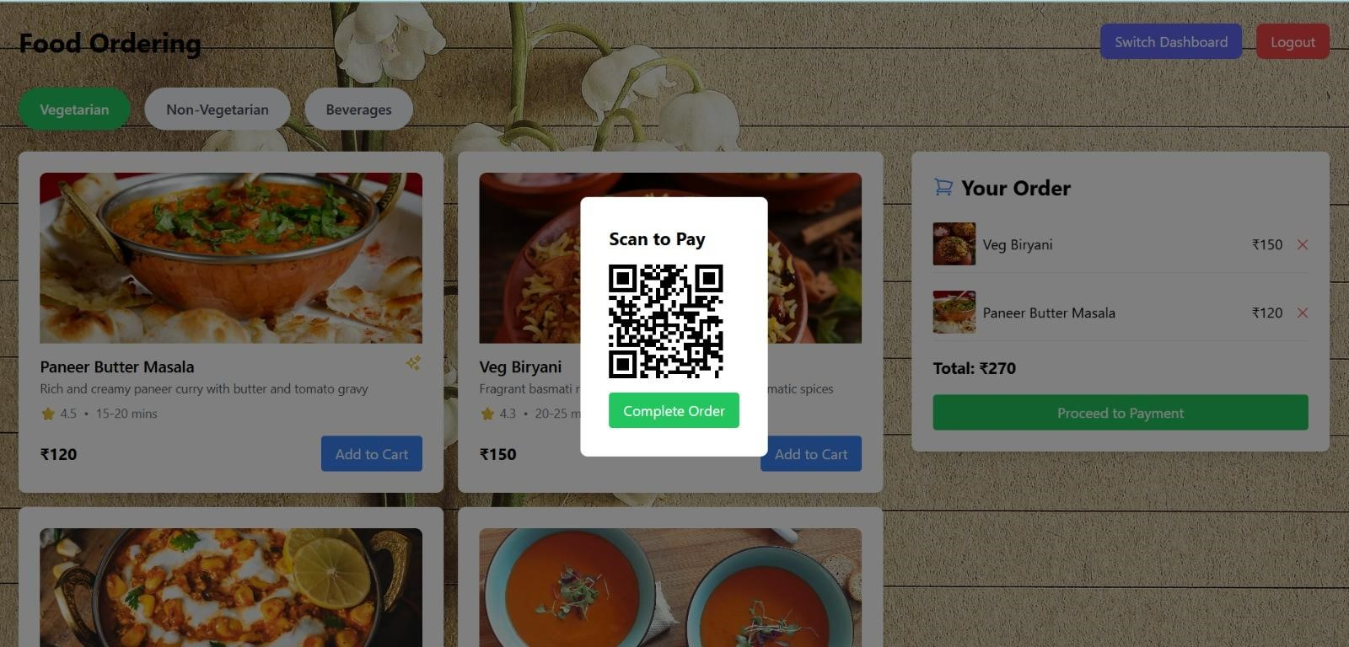

4. Cart and order summary screen in EduEats. It shows selected food items along with quantity, price, and a payment option.
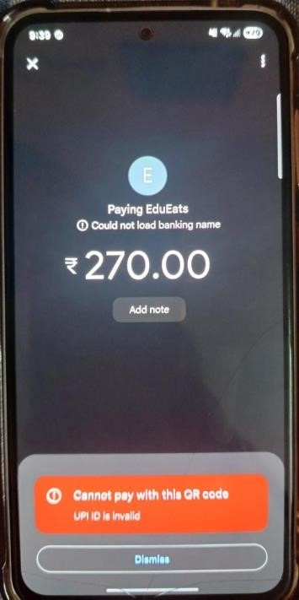
5. QR code payment screen for completing food orders. Users can scan the code using any UPI app for quick transactions.

6. EduPortal dashboard showing academic modules. Students can access notes, assignments, and academic calendars.
Students can also make discussion with others in student discussions section

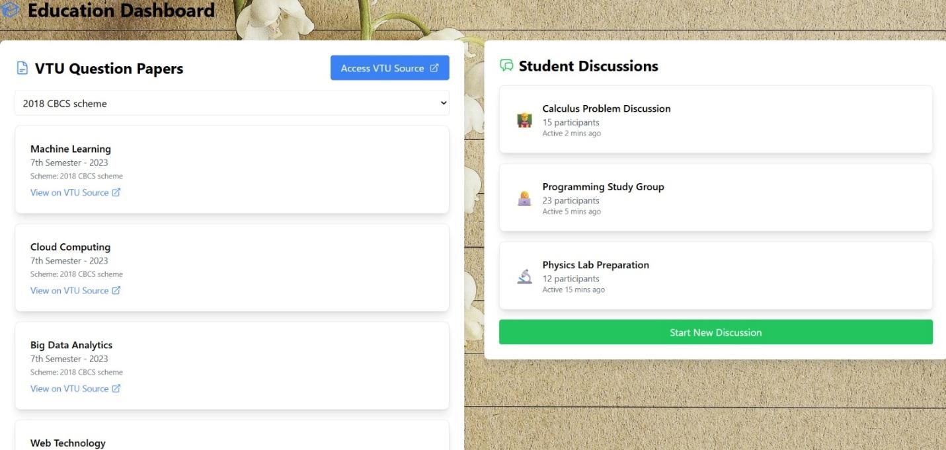

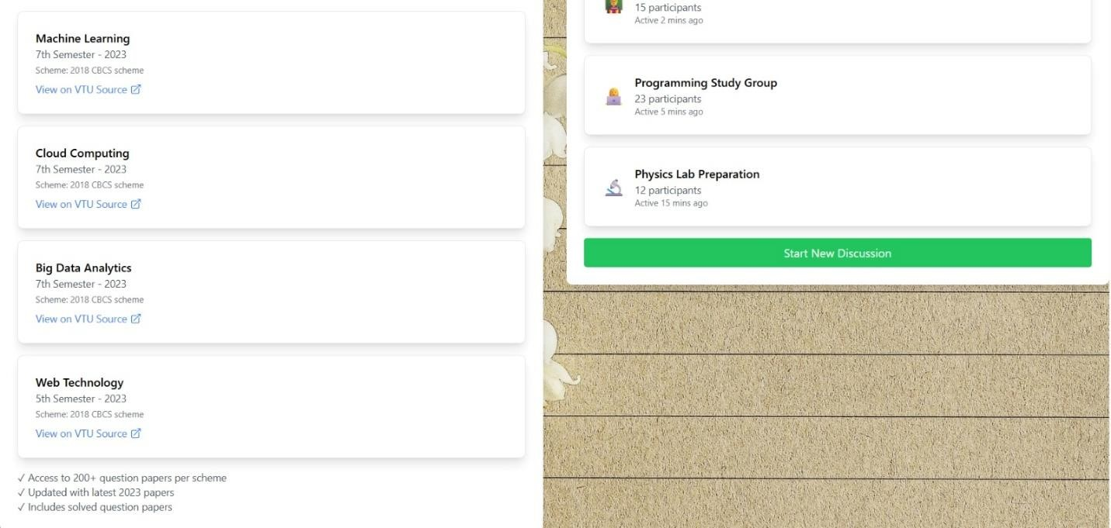

7. Students can view the resources and notes available on the vtu website based on their preferred topic.

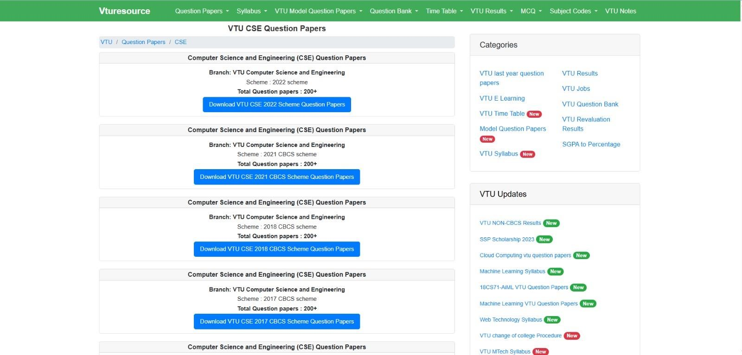

8. List of available VTU question papers. Users can download past exam papers for reference and study purposes.

EXPLANATION

How it Works:
- Landing page directs users to either dashboard.

- BrainBoard focuses on academic needs with clean card-based UI.

- CampusBites enables digital ordering from on-campus food outlets.

- Backend can be integrated to allow real-time authentication, database management, and payment processing.

Core Functionalities:

- Static pages supported by dynamic components.

- Cart and checkout system with UPI integration.

- Student-specific data rendered dynamically.

CONCLUSION
- ATRIA EDUEATS redefines the student experience by merging two essential needs — education and nourishment — into a unified digital platform.

- It reflects innovation in design thinking by addressing practical student requirements while promoting engagement, productivity, and convenience.

- This concept serves as a blueprint for future academics platforms that are not only informative and functional but also engaging and supportive of a well-rounded campus life.

- By combining academic dashboards with food services automation, ATRIA EDUEATS stands as a pioneer in student- centered digital innovation.

